**PROCEDURE OVERVIEW**

**1. Project directory**

G:\\SmartHome

**2. Data source**

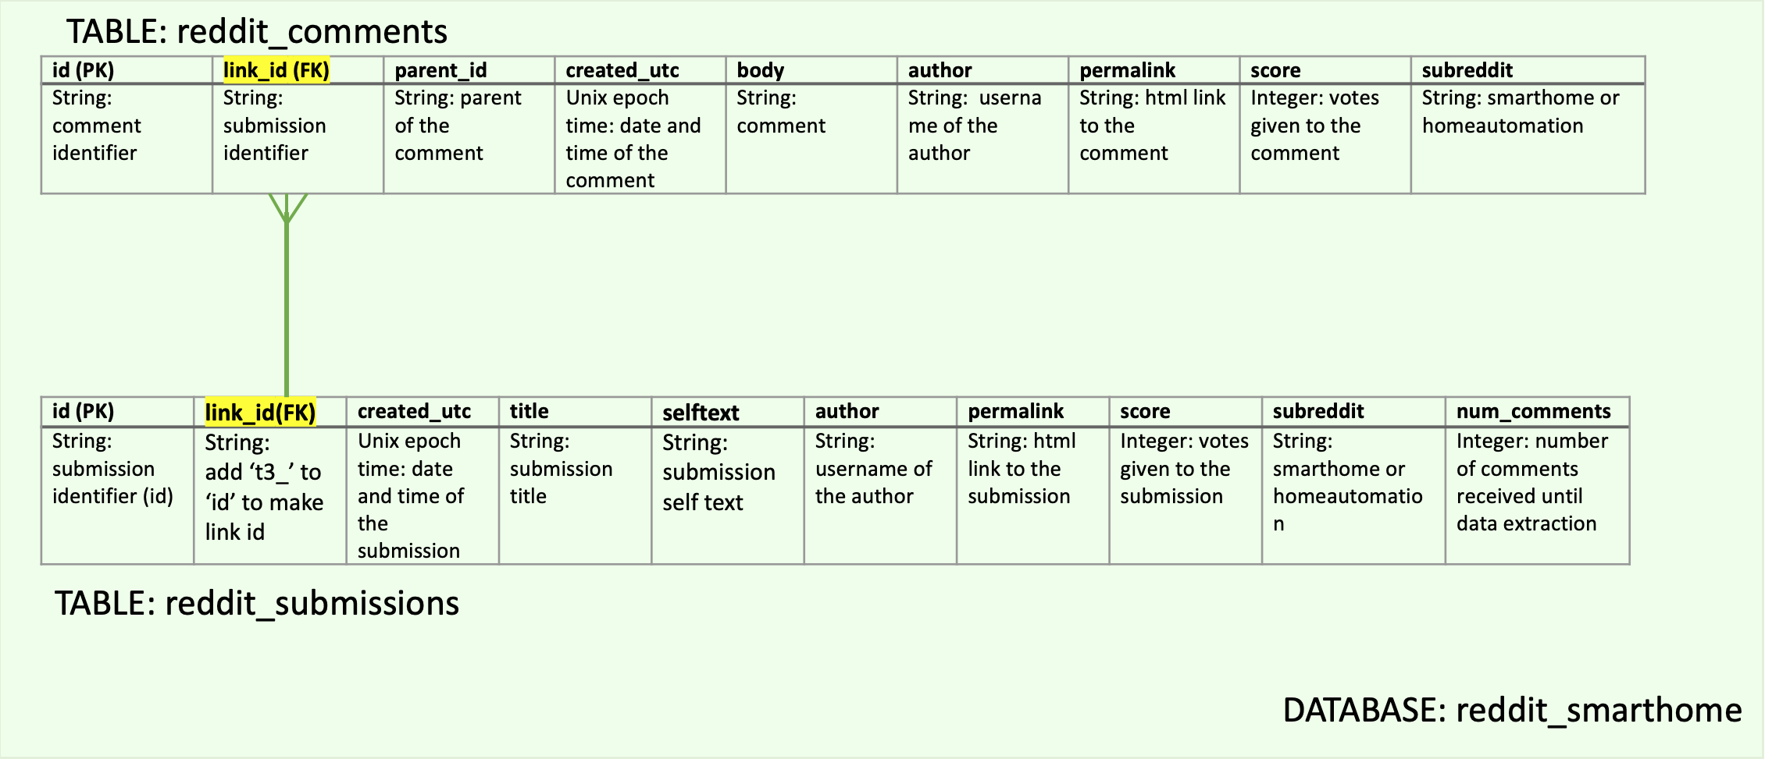

**Inputs: Output:**

From reddit_smarthome database: *.\\DataSource_backup\\df_tree.csv*

Source_Sub_OneTree.py

- reddit_comments Text on the form:

- reddit_submissions - a tree of comments sorted by tier

position and posting time

MySQL_data.py

recent

4 tier

3 tier

2 tier

1 tier

- random select 5000 comments

1ab

a

From each of the subreddits

1abc

(smarthome/homeautomation)

1abcd

2ab

- get the corresponding submission

2abcd

and all the comments within the

old

selected comment’s tree

Output Text: a+1ab+2ab+1abc+1abcd+2abcd

**3. Preprocessing**

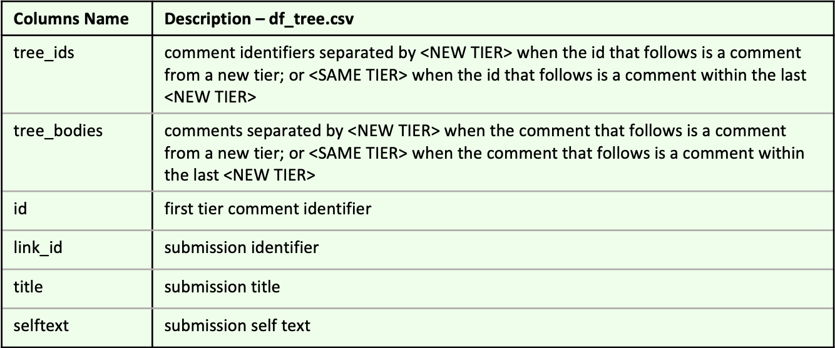

**Inputs: Output:**

NLP_preprocessing.py

*.\\DataSource_backup\\df_tree.csv* *.\\DataSource_backup\*

bot_test.py

*sub_onetree_train.csv*

*.\\DataSource_backup\*

*sub_onetree_test.csv*

- remove comments from bots

manually identified using bot_test.py

- remove comments where 70% words

are not in English

spelling_test.py

clean_text.py

- run a spelling check to see

If there are systematic errors

- deal with stop words, URLs, html formatting,

Internal hyphen, punctuation, lemmatization,

stemming

- remove row with short text

- divide the data in 80% training and

20% testing

**4. Visualization**

NLP_visualization.py

**-** words frequency from text - word count distribution

- vocabulary descriptive stats - words frequency from vocabulary

**5. Modelling**

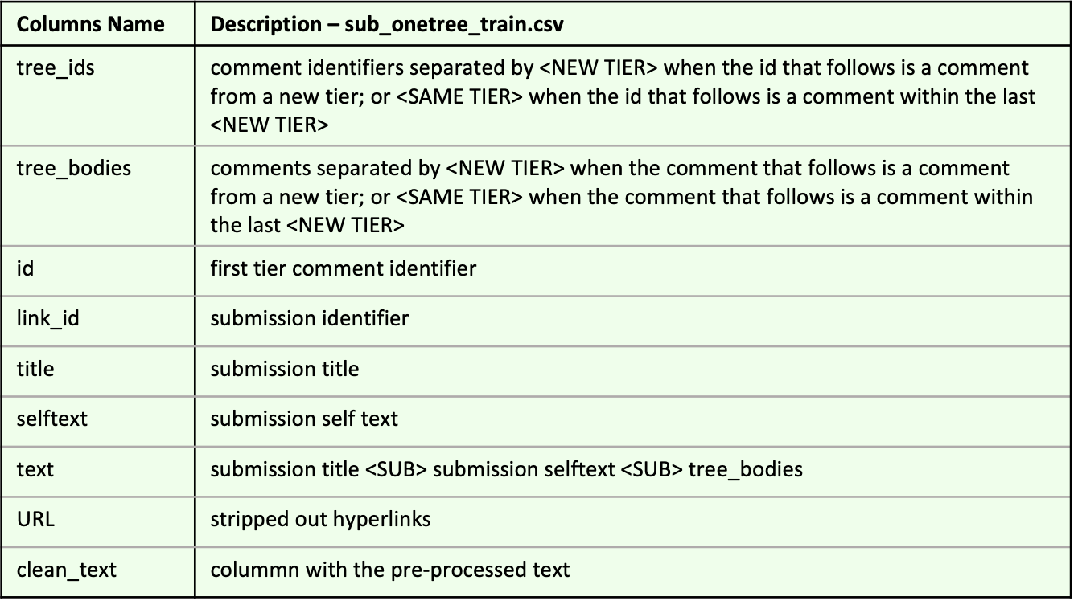

NLP_modelling.py

**Inputs: Output:**

*.\\DataSource_backup\* - trained vocabulary: **nb**xx_**na**xx

*sub_onetree_train.csv* [**nb**: no_below, **na**: no_above]

- trained models dict : **a**xx_**b**xx

[**a**: alpha, **b**: beta]

- trained bigram

- create bi-gram

- save trained bigram in \\venv\\lib\\site-packages\\

gensim\\test\\test_data\\train_bigram\\ nbxx_naxx_bigram.pkl

- remove from the vocabulary words

that occur too often and too infrequently

- save vocabulary in \\venv\\lib\\site-packages\\

gensim\\test\\test_data\\vocabulary\\nbxx_naxx

- run models and save in \\venv\\lib\\site-packages\\

gensim\\test\\test_data\\train_models\\ nbxx_naxx_axxx_bxxx_models.pkl

NOTE: working with 8GB RAM

**6. Evaluation**

NLP_evaluation.py

**Inputs: Output:**

*.\\DataSource_backup\* - In \\venv\\lib\\site-packages\\gensim\\

*sub_onetree_train.csv* test\\test_data\\evaluation\\

trained vocabulary - trained models dict : **a**xx_**b**xx

trained models - Calculate Coherence Gensim cv [**a**: alpha, **b**: beta]

trained bigram - Calculate Cao Juan 2009

- Calculate Arun 2010

- Calculate Coherence Mimno 2011

IMPORTANT: run evaluation from terminal with args: the trained vocabulary of interest and the alpha params

> python NLP_evaluation.py nb5_na04 a001_

> python NLP_evaluation.py nb5_na04 a01_

> python NLP_evaluation.py nb5_na04 a1_

> python NLP_evaluation.py nb5_na04 a10_

**7. Selection**

NLP_selection.py

**Inputs: Output:**

evaluation metrics in - In *.\\Figure\*

\\venv\\lib\\site-packages\\gensim\\

test\\test_data\\evaluation\\

- plot the evaluation metrics trends

in order to find the best combination

of alpha, beta and num. of topics

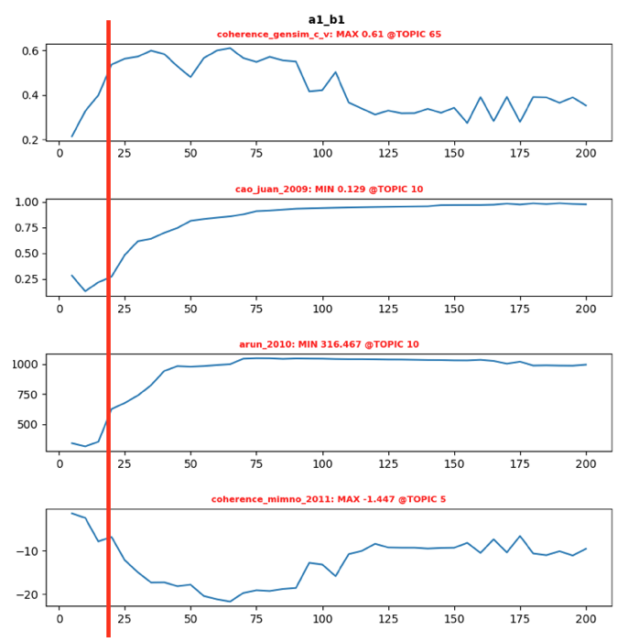

**7. Model Inspection**

LDA_classification.py

**Inputs: Output:**

selected trained model In \\venv\\lib\\site-packages\\gensim\\

trained vocabulary test\\test_data\\inspection\\

trained bigram - JSD calculation for all documents in

*.\\DataSource_backup\* nb5_na04_JSD_dict.pkl

NLP_inspection.ipynb/

NLP_inspection.html

*sub_onetree_train.csv* - Documents with JSD <= 0.4 to the

to the reference for each topic

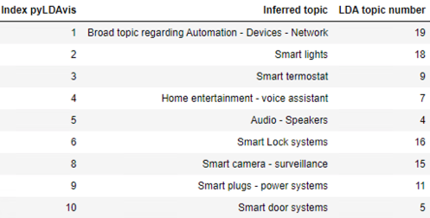 - top words per topic

- pyLDAvis

- summary output documents/topics

- Jensen-Shannon Distance

**8. Semantic Search Engine**

**Inputs: Output:**

ELMo_contextual_embeddings.py

Documents with JSD <= 0.4 to the

to the reference for each topic

- Semantic Search Engine

- Cosine Similarity